Assignment 3

To solve this algorithms assignment you must create a specific data structure which will reduce the time complexity. Since there are two types of nodes – ones with more than one “network port” and ones with only one “network port” we must create a field which differentiates between the two – singleConnect (bool).

The algorithm will consist of two separate modules. One to find the minimum spanning tree (MST) of all the nodes where singleConnect = false (those with > 1 port) and then another module to connect those nodes where singleConnect = true to the previous nodes.

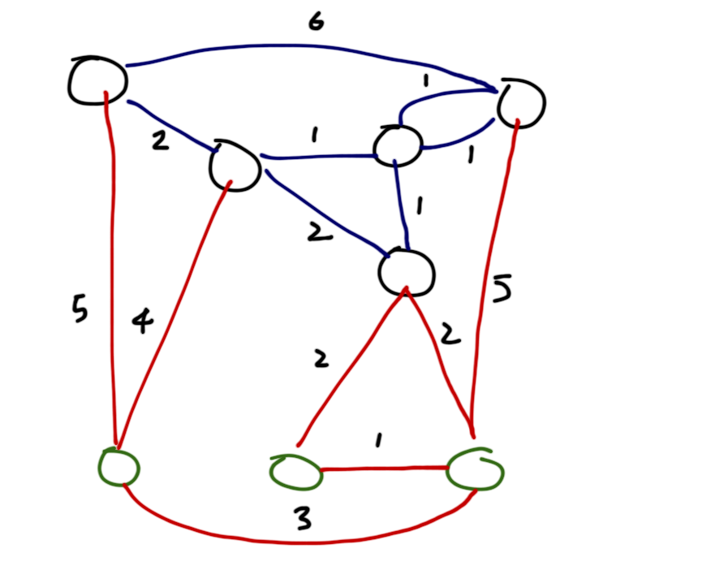
Lets use the graph below as an example. The black nodes have singleConnect = false while the green nodes are set to true. The blue edges go from black to black nodes, while the red edges go from green to black/green nodes.

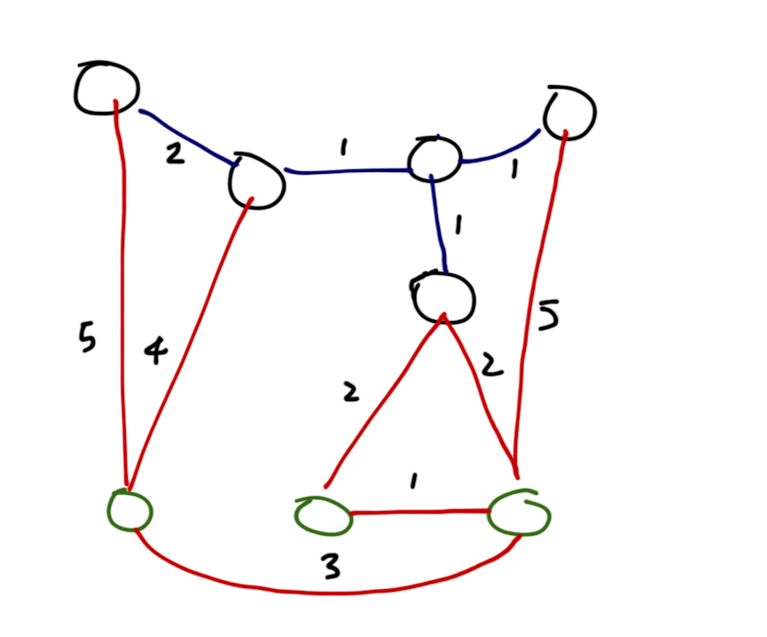
The first thing to do is run Kruskal's Algorithm on the black nodes on only the blue edges.

There are two conditions which must be taken into account when trying create the MST with the green nodes, while complying with the fact that there can only be one connection from/to any green node:
- No two green nodes can be directly connected to each other. This is because there is no way for either of those nodes to be connected back upwards to the black nodes without one of those nodes having more than 1 connection.
- The optimal edge back upwards will be the edge with the smallest cost. This is similar to the Kruskal's reasoning.

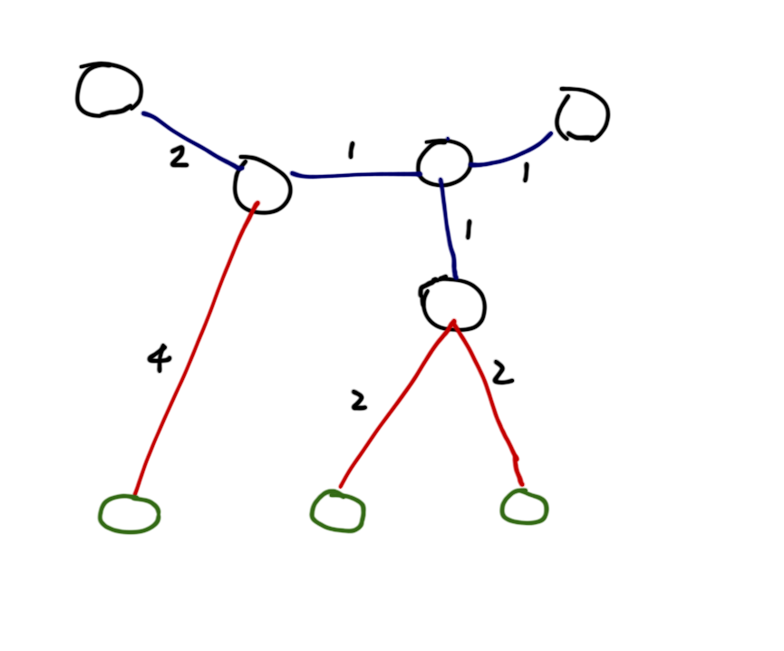
The second module also involves Kruskul's, but it is modified to fit the conditions listed above. You will end up with a connected yet MST graph that looks like this:

Algorithm and Running Time:

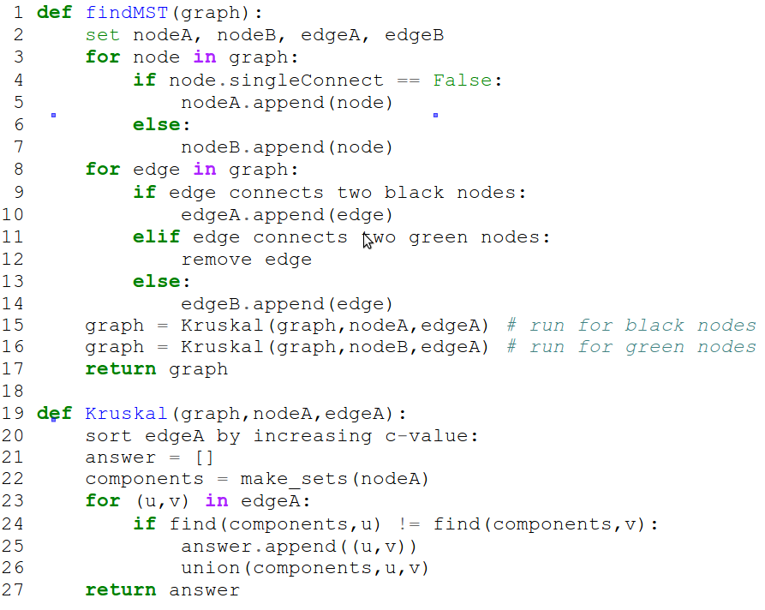

The running time of this algorithm is as follows:

- The 1st for loop takes O(n) time – iterating through nodes
- The 2nd for loop takes O(m) time – iterating through edges
- The Kruskals algorithm is run twice, each taking O(m log n) time – O(2m log n)

Total running time is simplified to O(m log n)

Note: The 2nd running of Kruskal takes the results from the 1st run thereby ensuring that once the top half is connected to every node in the bottom half (green nodes) through the union method, the algorithm will stop and the MST is attained.

